
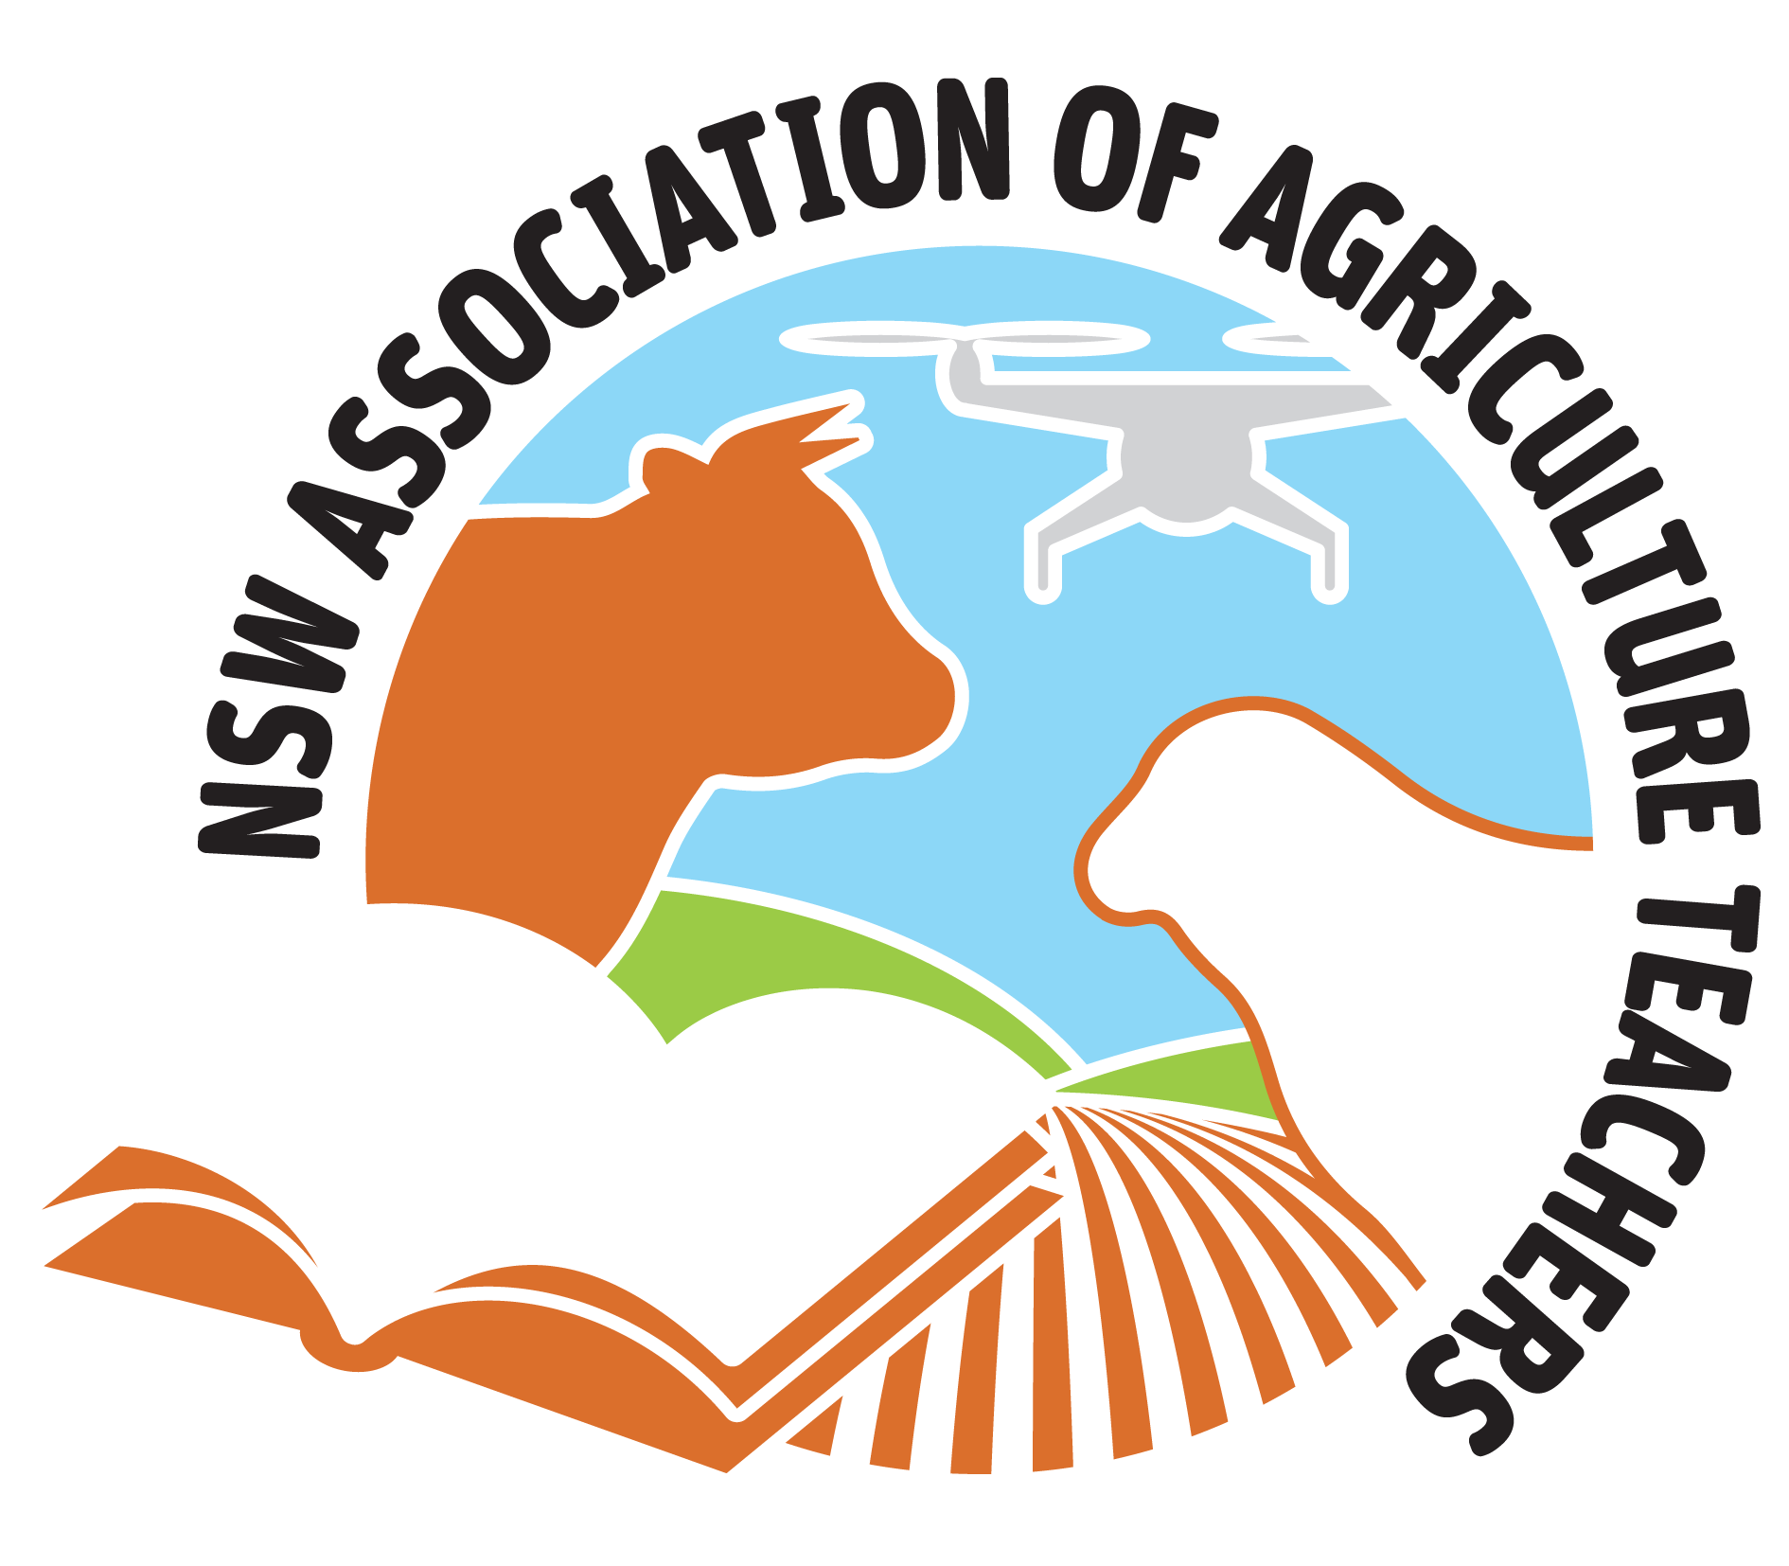
“Flat Out Farming” NSWAAT Central West Conference 2019
(Please note some activities may be subject to change at the discretion the committee due to current circumstances in the Central West)

Dates: 4th to 8th January 2019

Location: Forbes NSW

Accomodation: Plainsman Motel, 22 Sheriff St, Forbes NSW 2871.

Cost:
Members
$300 without accommodation
$620 with accomodation

Non Members
$360 without accommodation
$680 with accomodation

Final Cut Off Date: Friday 9th November 2018

For this price you will receive 4 nights’ accommodation at The Plainsman Motel,(if you choose the accommodation price) some meals, tours by bus of the Central West and what it has to offer, conference shirt, displays, presentations by sponsors, delegate gift bag, engaging and informative workshops, entertaining speeches, and a formal dinner at “Ëat your Greens” at Eugowra.
We are currently seeking accredited hours of QTC Registered Professional Development.
As you are aware the Central West is currently experiencing a drought. Despite this our committee has been working hard to showcase our area to you and to help further your knowledge to improve your teaching and learning in the classroom.


We hope that you can join us in your January school holidays to see what the Central West has to offer as well as catch up and share valuable knowledge with other NSW Agricultural Teachers.

We look forward to seeing you all. Flat Out Farming Committee.




Further Information: Hotel Overview
- All rooms are air-conditioned
- All rooms are on the ground floor
- Pool & BBQ facilities
- Breakfast Restaurant open 7 days
- Free WiFi & Foxtel Sports
- Conference facilities
- Free guest laundry
- Directly opposite the Forbes Services Club (RSL) with full Bistro/Café/Bar

This accommodation is shared. When filling out your forms please select a person you wish to share with. If no selection we will match a person of the same sex to share with you.
Please note there is no change to the conference price if you choose to come on selected days.
A bus will be taking you to and from the Plainsman to each location. If you source your own accomodation please meet at the Plainsman to catch the bus.
If you do not wish to share accomodation or are bringing your family for a holiday to Forbes. Please make your own accommodation arrangements at your own cost.

Please click on the links to our Forbes Shire Council Website for more information.

“Where to stay in Forbes” - http://www.forbes.nsw.gov.au/f.ashx/TCCD/Where-to-Stay.pdf

“Where to eat in Forbes” - http://www.forbes.nsw.gov.au/f.ashx/TCCD/Where-to-eat-2.pdf

Town map - http://www.forbes.nsw.gov.au/f.ashx/TCCD/Forbes-Town-Map-2017_PRINT.pdf

If you wish to bring a guest to the formal dinner please add $60 to your fee.
Adult only event.

Further Information: Contact Georgie Price

Email: georgina.bolam1@det.nsw.edu.au

Mobile: 0408 865 199

Proposed Conference Schedule
Friday 4th January 2019
Time | Place/Activity
3pm onwards | Arrive at the Plainsman motel
5pm | Welcome.
 | Dinner locally at one of our venues.

Saturday 5th January 2019
Time | Place/Activity
8am | Leave Plainsman
8:30 | Watermelon farm – tour and talk
9:30-10:30 | Pengillys shearing shed. AWI talk, Jemalong Wool, Biowaste
11:00 –12:30 | Gundamain feedlot – tour and talk
12:45 – 1:45 | Lunch - Gooloogong pub
2 – 2:40 | Eureka Roses – tour and talk
3:10 – 5:15 | Moxeys Dairy – tour and talk
7pm | Tea - Forbes RSL

Sunday 6th January 2019
Time | Place/Activity
8am | Tour of Matt and John Duff Summer cropping operations
10am | Lake Cowal for tour of mining operations and conservation centre. Visit to local Indigenous site.
3pm | Jemalong Irrigation scheme - irrigation in the 21st century
5pm | Tea - Posty

Monday 7th January 2019
Time | Place/Activity
7:30-8:45am | Saleyards - Central West Livestock Exchange and Forbes High School Farm
9 - 9:50 | Auswest seeds - trial information and tour
10-10:45 | Morning tea at Super Bee Café (McFeeters Motor Museum) BYO$
11 -11:45 | Group A Super Bee Honey Factory Group B Rat Breeding Facility
11:45-12:15 | Lunch @ Forbes Golf Club
12:30  12:30-1  1-1:30  1:30-2  2 -2:30  2:30-3  3-3:30  3:30-4  4-4:30  4:30-5 | At RBCC Rotations 30 mins each Delegates to choose ONE activity per rotation.  Group A - Kubota Group B - Gallagher  Wool judging workshop/ Trimble GPS demo / Stage 5 Ag New Syllabus  Low stress stock handling demo / Drones & Sensor probes / Judging workshop Vegetables  Animal Nutrition/ Judging workshop sheep/ Animals in Schools & Biosecurity  Afternoon tea and time to look at displays in the quad - Landcare, Local Land Services, DPI  Group A - Gallagher Group B - Kubota  Wool judging workshop/ Trimble GPS demo / Stage 5 Ag New Syllabus  Low stress stock handling demo / Drones & Sensor probes / Judging workshop Vegetables  Animal Nutrition/ Judging workshop sheep /Animals in Schools & Biosecurity  Leave RBCC to get ready for Conference dinner.
6:30  7pm till late | Leave Forbes - Plainsman Motel  Conference Dinner – Eat your greens Eugowra Dress – Semi Formal Speakers – TBA

Tuesday 8th January 2019
Time | Place/Activity
8:30am - | NSWAAT AGM @ Plainsman Motel Conference Room
 | Farewells and Departures.

NSW Association of Agriculture Teachers Biennial Conference
“Flat out farming”
4-8th January 2019 Forbes

Name:

School:
Address:

Your email:
Best phone #:
Pickup required: Yes / No
Location of pickup: Parkes Airport / Forbes Countrylink Bus
Date required to be picked up: Time required to be picked up:
Drop off required: Yes / No
Location of Drop off: Parkes Airport / Forbes Countrylink Bus
Date required to be dropped off: Time required to be dropped off:
Accomodation required : Yes / No
Names of people you are willing to share with:
1.
2.
If your husband /wife is a delegate of the conference please write this clearly on your form.
Dietary requirements:

Shirt size preference : Please circle your size.
Mens Size : XS / S / M / L / XL/ 2XL / 3XL / 4XL / 5XL
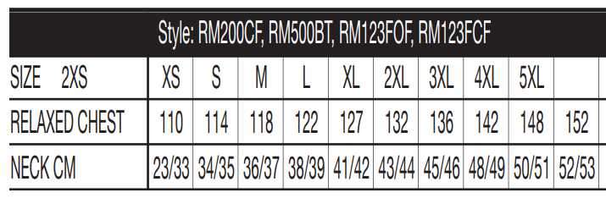
Ladies Size: 6 / 8 / 10 / 12 / 14 / 16 / 18 / 20
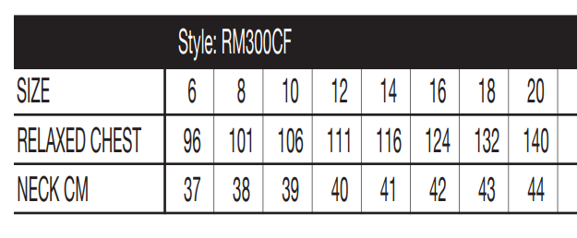
Workshop Choices Please Circle/highlight ONE preference per number.
NAME: ___________________________________________
Monday
- Superbee OR Rat breeding facility.
Monday Rotations
- Kubota OR Gallagher
- Wool judging workshop OR Trimble GPS demo OR NEW Stage 5 Agriculture Syllabus
- Low stress stock handling demo OR Drones & Sensor probes OR Judging workshop vegetables
- Animal Nutrition OR Judging workshop sheep OR Animals in Schools & Biosecurity
- Gallagher OR Kubota
- Wool judging workshop OR Trimble GPS demo OR NEW Stage 5 Agriculture Syllabus
- Low stress stock handling demo OR Drones & Sensor probes OR Judging workshop vegetables
- Animal Nutrition OR Judging workshop sheep OR Animals in Schools & Biosecurity
Attending the conference dinner: YES ◻ NO ◻
Additional Guest for dinner: YES ◻ NO ◻ (Add $60 to fee if a guest is attending)
Name of guest:
TOTAL FEE PAID: $ ____________ ◻Cheque ◻ or Direct Deposit ◻ or ONLINE
DO YOU NEED AN INVOICE FOR YOUR SCHOOL BEFORE PAYMENT?
CONTACT GRAHAM QUINTAL IMMEDIATELY AND HE WILL GET IT TO YOU IN A FLASH
treasurer.nswaat@gmail.com
PAYMENT OPTION 1: Please go online to NSWAAT website to pay for your conference.
PAYMENT OPTION 2: Direct Debit
BSB: 082 939
A/C No: 639 757 522
Reference: Your name and ‘conf18’
PAYMENT OPTION 3: Cheque made payable to
NSW Association of Agricultural Teachers (do not use NSWAAT)
SEND Cheque payment to Graham Quintal, P.O. Box 84, Swansea, 2281

Registration form to be sent to:
Attention: Georgie Price, NSWAAT, 36 Bedgerabong Rd , Forbes NSW 2871
Or scanned and emailed to georgina.bolam1@det.nsw.edu.au
Email confirmation for registration will be sent.

